2023-2024

FLOW CYTOMETRY Internship REPORT

|  |
| --- |
| INTRA-  and extracellular Flow cytometry |

Presented by

**Hajar EL Filaly**

Acknowledgement

I would like to acknowledge and show my immense gratitude for the **French association of Flow Cytometry** (AFC) for granting me such opportunity. This experience allowed me not only to learn Flow Cytometry but also to get to know new scientists in different fields.

I would also like to thank Dr. **Damien ARNOULT** for welcoming me into his laboratory, and Mr. **Denis Clay**, the platform’s engineer, for teaching me the basics and being available when needed.

# FIGURES LIST

**Figure 1: illustration of the Flow cytometry's systems. 6**

**Figure 2: BD Accuri C6 Flow Cytometer. 7**

**Figure 3: the BD LSR-Fortessa Flow Cytometer. 8**

**Figure 4: FITC Spill-over into PE. 8**

**Figure 5: Brefeldin A impact on the intracellular trafficking. 9**

**Figure 6: Comparison between permeabilized and non-permeabilized cells. 10**

**Figure 7: Gating technique. 11**

**Figure 8: Marked control and threshold setting. 11**

**Figure 9: Histogram assembling fluorescence results. 12**

**Figure 10: Statistican analysis in FlowJo. 13**

**Figure 11: schematic experimental design for the extracellular design. 14**

**Figure 12: Histogram plotting fluorescence relative to CD163. 15**

**Figure 13: Histogram depicting marked and non-marked controls' fluorescence. 15**

**Figure 14:Histogram plotting fluorescence relative to CD40. 16**

**Figure 15: Compensation window in FlowJo. 17**

**Figure 16: running a compensation when FITC contaminates PE in FlowJo. 18**

Contents

FIGURES LIST 3

OBJECTIVES OF THE MOBILITY 5

INTRODUCTION 6

**Flow cytometry: an overview** 6

**Experimental hypothesis** 6

**Characteristics of sed cytometers** 7

**Choice of fluorochromes’ combination** 8

AXIS 1: INTRACELLULAR FLOW CYTOMETRY 9

**Experimental design** 9

• **Brefeldin A** 9

**Samples preparation** 9

**Flow cytometry controls** 9

**Results’ analysis** 10

AXIS 2: EXTRACELLULAR FLOW CYTOMETRY 14

**Experimental design and sample preparation** 14

**Flow cytometry controls** 14

**Results’ analysis** 14

Compensation in FlowJo 17

CONCLUSION 19

# OBJECTIVES OF THE MOBILITY

To meet the AFC’s expectation, this mobility must meet the objectives consisting of Learning how to:

* Use cytometers and analysis software.
* Pic the right combination of fluorochromes.
* Pic the right controls.
* Prepare samples for both intra- and extra- cellular analysis.
* Correct spillovers through compensation.

# INTRODUCTION

## **Flow cytometry: an overview**

Flow cytometry is a complex technique merging hydrodynamics, optics, and electronics (Figure 1). To reach the excitation laser, cells are pushed by a hydrodynamic focusing, ensuring their alignment. Upon meeting the laser, cells will generate 2 types of light, light scatter, and fluorescence. Light scattering is the deflected light generated when the laser hits the cell and is measured in two different directions: The forward direction (**Forward Scatter** or FSC) which reflects the size of the cell and at 90° (**Side Scatter** or SSC) which depicts the intracellular complexity or granularity of the cell. As for fluorescence, it can be defined as the emitted light generated upon the excitement of a fluorochrome. To be detected, this emitted light will go through filters that will collect and purify this signal to be detected by appropriate detectors. Lastly, a digital conversion is necessary to translate the photonic signal to an electronic one that can be computed and thereby analyzed.

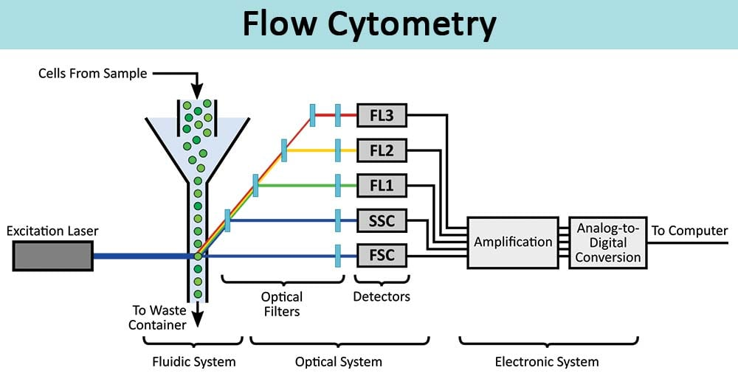

Figure 1: illustration of the Flow cytometry's systems.

## **Experimental hypothesis**

*Helicobacter pylori* (*H. pylori*) is a spiral gram-negative bacterium with flagella, and was first isolated by Warren and Marshall in 1982 (Robinwarren 1983; Warren 2000). Classified by the World Health Organization (OMS) as a class I carcinogen, *H. pylori* infection is associated with various pathologies ranging from simple asymptomatic gastritis to more serious pathologies such as gastric cancer (den Hoed and Kuipers 2020). *H. pylori* LPS was depicted as carcinogen through in vitro studies using gastric epithelial cell lines. However, and upon its exposer to immune cells such as macrophages and dendritic cells, *H. pylori* LPS is less endotoxic than other well-known LPSs (for example: *E. coli*) (Chmiela, Miszczyk, and Rudnicka 2014), and barely induced proinflammatory cytokines such as IL-1β, IL-6, IL-8 and TNF-α (Fujimoto et al. 2012).

Since no data has been found on long term exposer of LPS regarding immune cells, Flow Cytometry will be used to assess its effect on THP-1 polarization at both intra- and extra-cellular levels.

## **Characteristics of sed cytometers**

2 cytometers were used during my internship, the BD Accuri C6 (Figure 2) and the BD LSR-Fortessa (Figure 3). The BD Accuri C6 is equipped with a blue and red laser and two light scatters and is suitable for the well-known fluorochromes such as PE, APC and FITC. This cytometer does not require the adjustment of detector voltage. In contrast, the BD LSR-Fortessa requires the voltages adjustment. This cytometer is configured with up to 5 lasers: blue, red, violet, UV and yellow green. In fact, the Fortessa is the optimal cytometer to use when having multiple targets to assess at once.

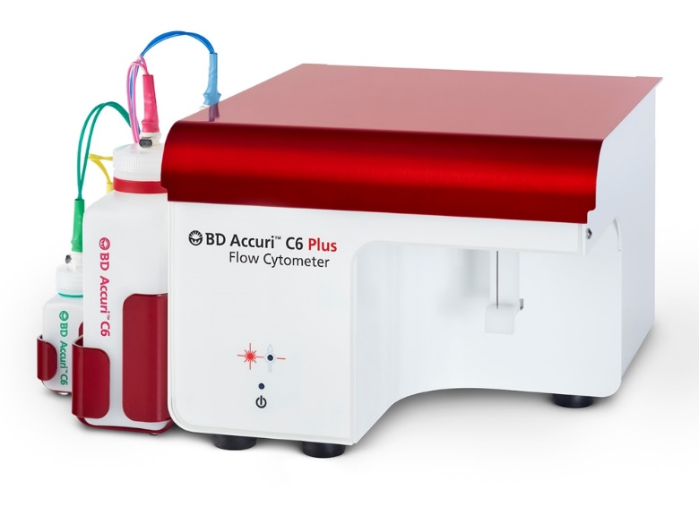

Figure 2: BD Accuri C6 Flow Cytometer.

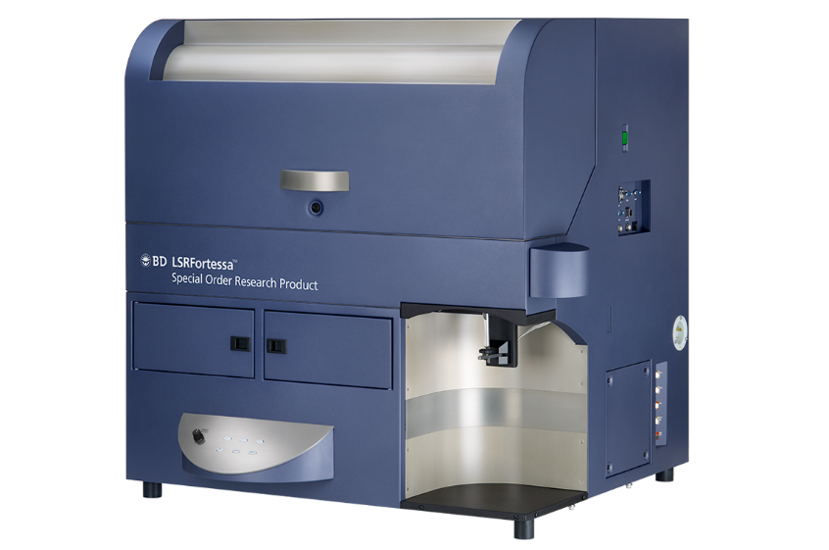

Figure 3: the BD LSR-Fortessa Flow Cytometer.

## **Choice of fluorochromes’ combination**

To optimize time, and when able to use Flow Cytometry, assessing different targets at once is considered. The used combination of fluorochromes must ensure that the detected emission is a “pure” signal for one targeted molecule. To do so, spill-over must be avoided. This phenomenon can be explained by the contamination of the detection gate of a fluorochrome assigned for another fluorochrome.

As an example, FITC and PE can be the perfect example to explain the spill-over phenomenon. In Figure 4, the FITC emitted light (green) is “spilled” into the PE detection gate, thereby polluting the detected PE light. This phenomenon can be corrected by “compensation” (see page 16).

**Figure 4: FITC Spill-over into PE detection gate.**

# AXIS 1: INTRACELLULAR FLOW CYTOMETRY

## **Experimental design**

THP-1 were stimulated with 1 µg of *H. pylori* LPS for 7 days. In the 7th day, Brefeldin A was added for 4h hours prior staining.

### **Brefeldin A**

To assess the intracellular content, Brefeldin A is used to trap the molecules inside of the cell through blocking the ER-Golgi vesicles trafficking (Figure 5).

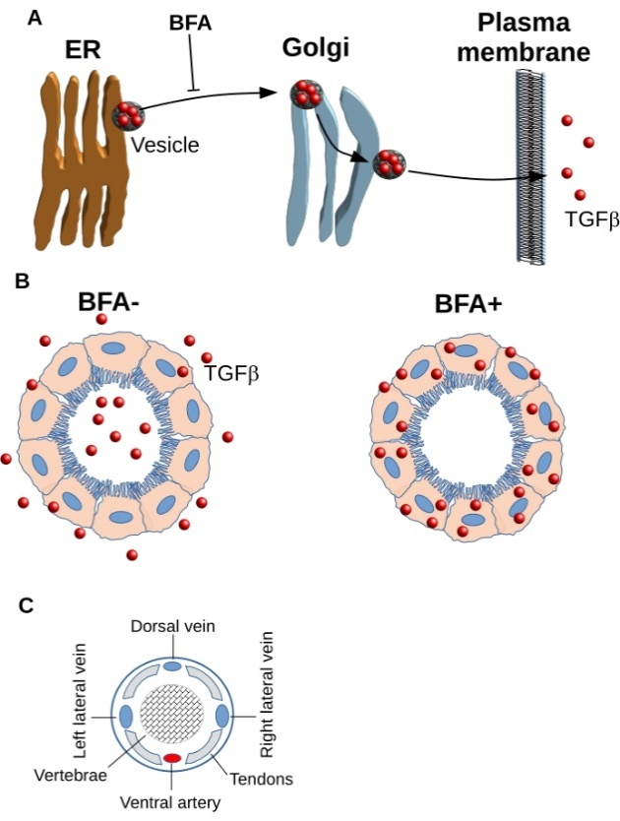

Figure 5: Brefeldin A impact on the intracellular trafficking.

## **Samples preparation**

Cells were harvested in Eppendorf tubes and were washed once with PBS. Prior staining, cells were fixed and permeabilized using the BD CytoFIX/CytoPERM kit (Cat. No. 554714). Cells were stained using BD anti-IL-10-APC and BD anti-IL-1β-PE.

## **Flow cytometry controls**

Flow cytometry requires controls ensuring optimal experimentation and consistent results.

1. Non-permeabilized Brefeldin A –: To ensure that cells were properly permeabilized, a non-permeabilized control is required.
2. Permeabilized Brefeldin A – and Permeabilized Brefeldin A +: assess Brefeldin A effect on THP-1 since it might affect cell viability.
3. Mono-marked controls: even though no compensation is needed, these controls were added to ensure the staining quality of each fluorochrome.
4. Marked control: To set a threshold and compare between stimulated and non-stimulated.

## **Results’ analysis**

This analysis was carried out using the BD Accuri C6 and results’ analysis was done using FlowJo v.10.9.0.

the shape of the permeabilized THP-1 cells change exhibiting a decreased size and slight increase in granularity when compared to non-permeabilized ones.

Figure 6: Comparison between permeabilized and non-permeabilized cells.

For a proper analysis, cells of interest must be gated properly (Figure 7). By plotting the cells in an FSC-A/SSC-A, the main live population is gated and named (THP-1 perm). Afterward, the selected population will be plotted using FSC-H instead of SSC-A to select single cells and discard doublets. These might show increased fluorescence and will falsify the final results.

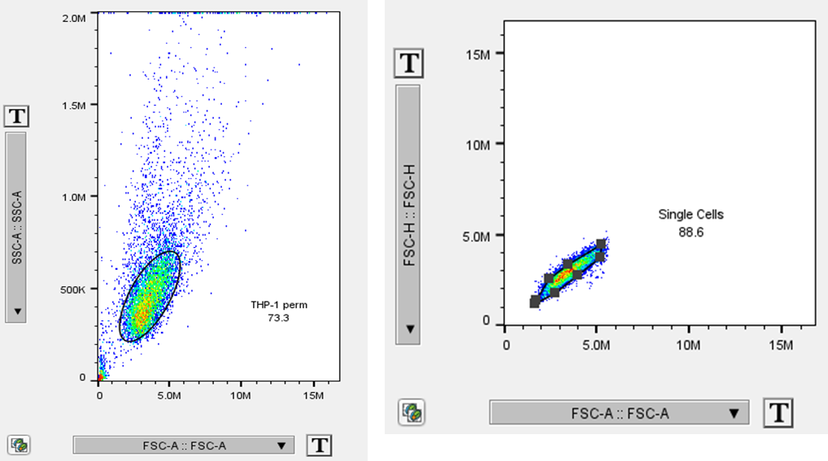

Figure 7: Gating technique.

To start comparing the stimulated cells to non-stimulated ones, the marked control will be used to set a threshold of fluorescence (Figure 8).

Figure 8: Marked control and threshold setting.

Histograms are another way of visualizing results. In Figure 9, the IL-10-APC fluorescence of each sample was visualized and the median of each one was added to the labeling table. At first glance, no difference is noted between the marked control and Hp-stimulated THP-1 unlike Ec-stimulated ones.

Figure 9: Histogram assembling fluorescence results.

Since no conclusion can be decided upon observation, FlowJo tools allow the user to have an idea on whether the difference is significant or not through Chi- Squared T(X) value. This value is inversely proportioned to the *p.* value; Higher Chi- Squared T(X) value reflects a smaller p. value and vice versa. In conclusion, no difference between IL-10 levels of Hp LPS-stimulated THP-1 is exhibited when compared to non-stimulated control, unlike Ec LPS stimulated THP-1, showing an increased level of IL-10 (Figure 10).



Figure 10: Statistical analysis in FlowJo.

# AXIS 2: EXTRACELLULAR FLOW CYTOMETRY

## **Experimental design and sample preparation**

The experimental design is described in Figure 11. For extracellular flow cytometry, cells were harvested, washed, and then stained using BD anti-CD40-BV421 and BD anti-CD163-PE. Analysis was carried out using the BD LSR-Fortessa.

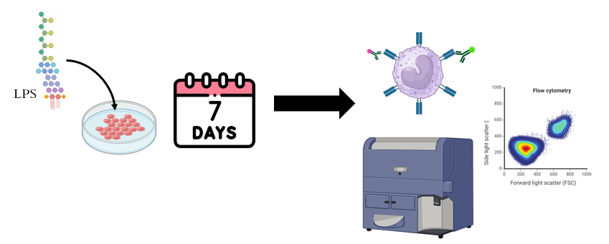

Figure 11: schematic experimental design for the extracellular design.

## **Flow cytometry controls**

1. Non-marked control: Since the BD LSR-Fortessa will be used, this control will serve for setting the detector’s voltages.
2. Mono-marked controls.
3. Marked control.

## **Results’ analysis**

Using the same gating strategy, fluorescence was plotted for both CD163 (M2 marker) and CD40 (M1 Marker). Surface CD163 showed no difference upon stimulation (Figure 12).

Figure 12: Histogram plotting fluorescence relative to CD163.

When plotting non-marked and marked controls, non-stimulated THP-1 are shown to express CD40 (Figure 13). Using the same statistical analysis tool, the difference between marked and LPS Hp or LPS-Ec-stimulated THP-1 was not significant (Figure 14).

Figure 13: Histogram depicting marked and non-marked controls' fluorescence.

Figure 14:Histogram plotting fluorescence relative to CD40.

# Compensation in FlowJo

As described above, compensation is a way of correcting spillovers. To run a compensation, Anti-CD-86-FITC and anti-CD163-PE were combined in one experiment. Through Compensation matrix, spillover correction can be done manually but can also be done automatically when having many compensations to do.

When opening the compensation window, a matrix will appear where the rows are the contaminants fluorochromes and the columns represent the contaminated detection gates (Figure 15).

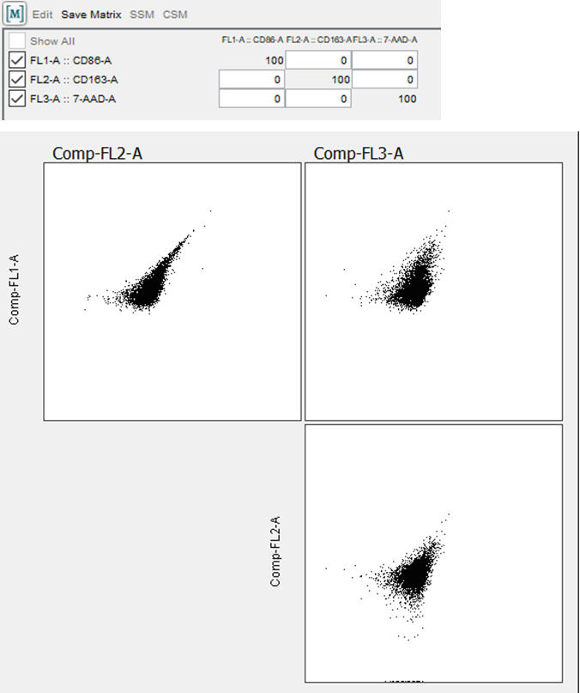

Figure 15: Compensation window in FlowJo.

When changing the value, the plot corresponding to CD163 changes the shape and samples are eventually ready to be analyzed (Figure 16).

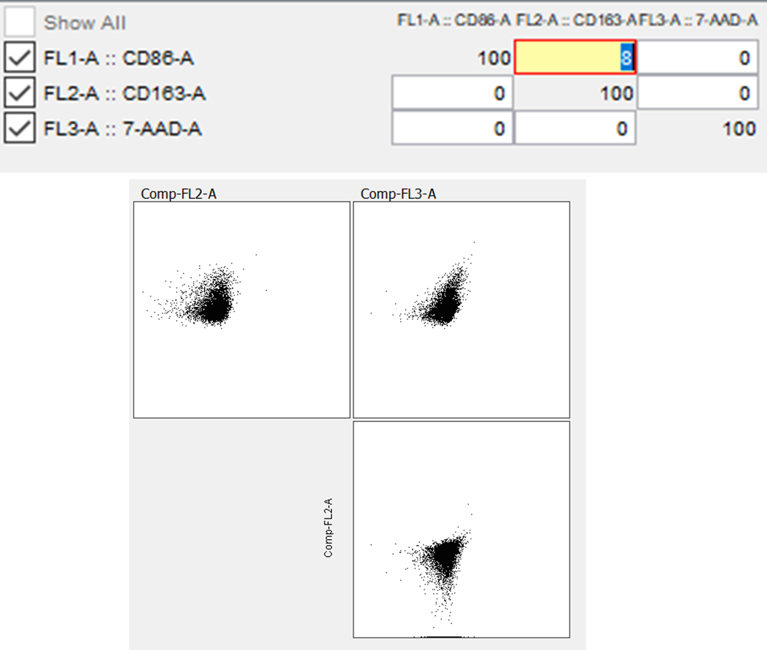

Figure 16: running a compensation when FITC contaminates PE in FlowJo.

# CONCLUSION

Overall, flow cytometry is an excellent tool for analyzing multiple targets at once. Thanks to this mobility program, I was able to learn flow cytometry in details including the samples preparation, the choice of fluorochromes and running proper analysis after using the cytometer, allowing me to use and help other scientists to use Flow Cytometers in Moroccan platforms. In addition, I got to use flow cytometry in the context of my PhD project as a way of optimizing the internship and benefiting the flow of my thesis problematic.